Rustic Ridge Association
Annual Meeting Minutes - Draft
Saturday, August 3, 2024
Trinitarian Congregational Church.

Call to Order – Bob Ziegenhagen, Clerk called the meeting to order at 9:45 AM. There were 31 people in attendance.

Invocation – Dennis Campbell opened with a prayer for peace and understanding in the world and within our country.

Minutes of the 2023 Annual Meeting were approved without amendment. A copy is on the RusticRidge.org website under “Ridge Association / Meeting Minutes”.

Town Report - Heather Tower, Town-Ridge Liaison reported on developments in Northfield over the past year. A copy of her notes is attached but highlights follow:
- Thomas Aquinas is at full enrollment
- The Police force fully staffed
- Schell Bridge construction is still postponed, awaiting next steps from Federal and State authorities.
- Cameron’s Winery and 4 Star Brewery are active and doing well.
- First Light’s Northfield Mountain license renewal is still up for discussion.
- CS Lewis continues to offer excellent programs.
- Town is eagerly waiting for the area next to the IGA to open with space to sit and eat.
- The Fire Department, Police Department and EMS are still looking for new accommodations after the town voters recoiled from the high projected cost of the combined emergency services building.

President’s Report – Trish White offered several comments:
- The Tennis courts are in great shape and thanks go to the Livingstons, Doug Denise and to Thomas Aquinas College. Trish advised that contributions for the courts should go to Thomas Aquinas Collage to get the appropriate tax credit.
- Two new Ridge members were highlighted; Kurt Nelson spoke of the Sullivans from Boston who bought Friendship lodge and are already customizing the cabin. In addition, Martha Stinson bought 18 West Lane, returning after several years away.
- There are Open houses scheduled for two cottages currently for sale on the Ridge: the remodeled old Santos cabin on 14 Wood Way and the Fergeson’s Cabin at 17 West Lane.
- The annual list of summer theater programs put together by the Sorenson’s is immensely informative and worth a close perusal.
- Negotiations continue on merging Northfield’s two water systems. As usual, the East Northfield Water Company’s water quality report was positive this year.
- The Library offers very interesting presentations, including this afternoon’s discussion on raptors.

Guest Speaker: Library – Misha Storm, Director of Northfield’s Public Library highlighted the library’s extensive resources and services. As part of an integrated network of Western Massachusetts libraries, the Dickenson Memorial Library is much more than just a small-town library. It offers extensive historical records, audible books, intrastate book transfers, games, puzzles, passes for the museum and pool, a fast Wi-Fi hot spot, weekly adult educational programs and digital resources online.

Roads Report – Lucy Livingston reported that the budget was only partly spent this year because we deferred repairs to Cliff Road, seeing as the town didn’t finish the prerequisite North Lane repairs. Tommy Walker again said North Lane will be repaired this fall. After those repairs, Cliff Road will be mended partly with asphalt and partly with gravel. Following that, repairs on Heath Road will be investigated.

The main activities this last year were the usual annual maintenance, the addition of a warning sign at the top of the steep Ledge Way, and storm repairs near Kip Kritchko’s property. Finally, Lucy thanked Lindsey Lack for stepping in to be co-chair of the Roads Committee. Later, after the meeting was over, Phil Sherburne accepted the other co-chair position. Lucy will work with the new team to ensure a smooth transition. A copy of the Road Committee’s report and budget are attached.

Financial Report – Doug Denise, Treasurer, reported that we ended up 2023-24 with a strong cash position $27,970 due to a significant underspending of the Roads budget by -$7,215. Revenues were slightly below budget at $10,086, given payments by 56 of our 63 cottages and 26 Associates. Given normal Road Committee spending next year we should end the year with a lower cash balance of $21,043 if we kept the same dues structure. If we increased dues, as the Board recommends, the cash position would be a stronger $23,853.

Doug and Trish led a general discussion of the need for a member dues increase from $150 to $200 annually and an associate increase from $40 to $50. An increase of this magnitude seems in order seeing as our last increase was in 2015 and cumulative inflation since then totals over 30%. A motion to approve the Board’s dues increase was moved, seconded and unanimously approved.

A motion was approved to have the Board consider increasing the payment to Steve Severance for trash collection from $150 per pickup to $200. Members of the Board advised that we just increased his compensation last year from $100 to $150 and that Steve was reluctant to accept even that increase.

A question arose on the proper size of our reserve. The Board replied that the Ridge’s main need for a reserve (besides normal cash flow coverage) was to cover unanticipated Road expenses, should there be damage from a serious weather event. That number appears to be about $25,000 but we need to do some analysis to review that number.

The Treasurer’s report and budget are attached.

Social Activities Report - Jean Bubriski reported that we are enjoying a full slate of successful activities this year. She thanked the many Ridge people who have hosted events this year, including:

- Margie Conner for her coordination with the Trinity Congregational church for the Summer Luncheon and Ridge Sunday.
- Lynzi Ziegenhagen and Lindsey Lack for hosting the July 4 Parade Reception, which at least 40 people of all ages attended.
- Carolee Z. and Emelie Collet for organizing the July 6 Potluck Dinner which 60 people attended.
- Catherine Broadhead for hosting Arts and Crafts and Bingo and the Block Party on August 4th afternoon.

Memorials – Kurt Nelson led a moment of silence and remembrance of the seven Ridge individuals who passed since last year:

- Jocelyn Mary Walker, July 15, 2024
- Warren Snyder, May 17, 2024
- Jim Broadhead, April 9, 2024
- Marybelle Chapin, April 7, 2024
- Julia Voorhies, March 3, 2024
- Milt Djuric, December 2023
- Larry Whitney, November 24, 2023

Obituaries for these friends are on the RusticRidge.org website.

Nominating Committee – Carolee Ziegenhagen, speaking for the Nominating Committee of John Powell, Margie Connor, Leesa Campbell, Trish White and herself proposed a slate for 2024-25. It was seconded and unanimously approved.

President Chris Martin
Vice President John Powell
Treasurer Doug Denise
Clerk Bob Ziegenhagen

New directors for Class of 2027:
Katie Young
Caroline Collet Bellum

Class of 2026: Class of 2025:
Phil Sherburne Emelie Collet
Marianne Chenoweth Alex White (For John Powell)

Adjourn – There being no further business, the meeting adjourned at 11:08 AM.

Submitted August 4, 2024 by Bob Ziegenhagen, Clerk
Annual Meeting Rustic Ridge Association 8/3/24
Agenda

Call to Order Bob Ziegenhagen, Clerk
Invocation Dennis Campbell
Approval of 2023 Annual Minutes
President’s Report Trish White
Memorials Kurt Nelson
Town Report Heather Tower, Town Liaison
Library Report, Misha Storm, Head Librarian of the
Dickinson Memorial Library
Road Committee Report Lucy Livingston
Treasurer’s Report Doug Denise
Board Proposal to increase dues Trish White
Discussion
Vote
Social Committee Report Jean Bubriski
Nominating Committee Report Carolee Ziegenhagen
Proposed Slate
President Chris Martin
Vice President John Powell
Board member to serve the remaining year of John Powell’s Board Term
Alex White
New Board Members class of 27 Caroline Bellum, Katy Young
Continuing Board Members are
Emelie Collet, class of 25,
Marianne Chenoweth and Phil Sherburne class of 26.
Election
New Business
Adjourn

Treasurer’s Report
Rustic Ridge Association Annual Meeting
August 3, 2024

The following report will be easier to follow by looking at budget document emailed in advance and distributed today as a handout.

We began the year last August 1 with a balance of $27,970 in the bank. This number is at the top of the middle column of budget handout. We ended the year on July 31 with a bank balance of $28,683, number at the bottom of middle column and top of right-hand column - Starting Cash Balance-Aug 1.

Looking again at middle column - for year ending July 31, 2024, we had total revenues of $10,799. Dues income from Active Members (cottage owners) was $8,227, Associate Member dues added $1,014, bank interest was $9 and Reserve Fund donations were $1,549.

Below revenues (middle column) are expenses for FY23-24. These totaled $10,066 this past year. Amounts listed below the total show expenses in each budget category. You can see our four largest expenses – looking down the page, as follows:
Community Contribution - $1,000,
Insurance (for Directors & Officers Liability) - $1,083,
Road Maintenance – $3,790 - always largest expense, though this year well below planned amount due to Cliff Road delay,
Trash collection - $2,400.

Any questions about any FY23-24 Revenues or Expenses?

Next, is a review of Board approved budgets for FY24-25. These are shown in the right-hand columns of Budgets A & B.

This year, because of proposed dues increase, there are two budgets – Budget A (Same Dues) and Budget B (Increase Dues). After our vote today, we will have one budget. The only difference between them is the additional revenue shown in Budget B.

Budget B (Increase Dues) has revenues projected at $13,908. In Budget A (Same Dues) revenues are projected at $11,098.
The additional revenue in Budget B is $2,810.

Expenses in both budgets are the same – at $18,738.
Again, the four largest expenses are the same as for FY23-24 (middle column). The left column which shows Revenues and Expenses for FY22-23 shows the same pattern.

For FY24-25 (right column), the amount budgeted for Road Maintenance is $11,650. The three other largest expenses for FY24-25 are Community Contribution - $1000, Insurance - $1,083 and Trash Collection - $2,400. Please note: other expenses listed are for activities that in various ways enhance our Ridge community - not highlighted in this report for the sake of brevity.

Ending cash on July 31, 2025, is listed at $23,853 in Budget B (Increase Dues). In Budget A (Same Dues) the ending cash is $2,810 less at $21,043.

Any questions about the FY24-25 budgets – Budget A or Budget B?

Thank you!

Additional Information (Supplement to Verbal Report)

1. Calculation of revenue in FY24-25 if Board proposed dues increase is approved: For Active Members: $50 more per cottage times 57 expected payments in FY24-25. For Associate Members: $10 more per Associate family times 26 expected payments in FY24-25. For reserve fund donations, the amount listed is $300 less than amount in FY24-25 budget if annual dues remain the same. The reduction is based on a prediction of fewer donations if dues are increased. Interest revenue is reduced in both in anticipation of lower interest rates.

2. In the fiscal year just ended, revenues declined compared to the prior year. Due mostly to lower road maintenance costs (expensive project delayed), total expenses decreased by $6,656 compared to last year. Our end of year cash balance increased from $27,970 to $28,683.

FY21-22 FY22-23 FY23-24

Revenues $11,327 $11,400 $10,799
Expenses $11,071 $16,742 $10,086
Year-End Cash: $33,312 $27,970 $28,683

3. Of 63 Member owned cottages, dues were paid for 56 cottages, three less than last year.

4. Dues payments for our Associate Member families numbered 26, one less than last year.

5. Voluntary member donations (Reserves) were $1,549 in FY2023-24. In FY2022-23 they were $1,706. This is about a 10% decline and the lowest amount in 12 years: well below 10-year average of $2,313.

6. An analysis of reserve fund donations going back to August 1, 2012 (before which records are unavailable), shows that donations account for $18,592 of our total cash balance today of $28,683. Stated another way, without these donations, our current cash balance would be $10,091. In addition, during 6 of the past 12 years, annual expenses have exceeded revenue from dues alone. Clearly, reserve fund donation have been a key to stable finances.

7. The Rustic Ridge Association PayPal account was available for dues and contributions again this past year. Forty-three (43) Members paid this way. All PayPal payments (less PayPal fees) were transferred to our Rustic Ridge Association bank account at Greenfield Cooperative Bank.

8. Massachusetts Secretary of State Corporation Annual Report filed 11.9.23.

9. Our Federal Tax Return Form 990-N for FY2022-23 was filed 11.28.23.
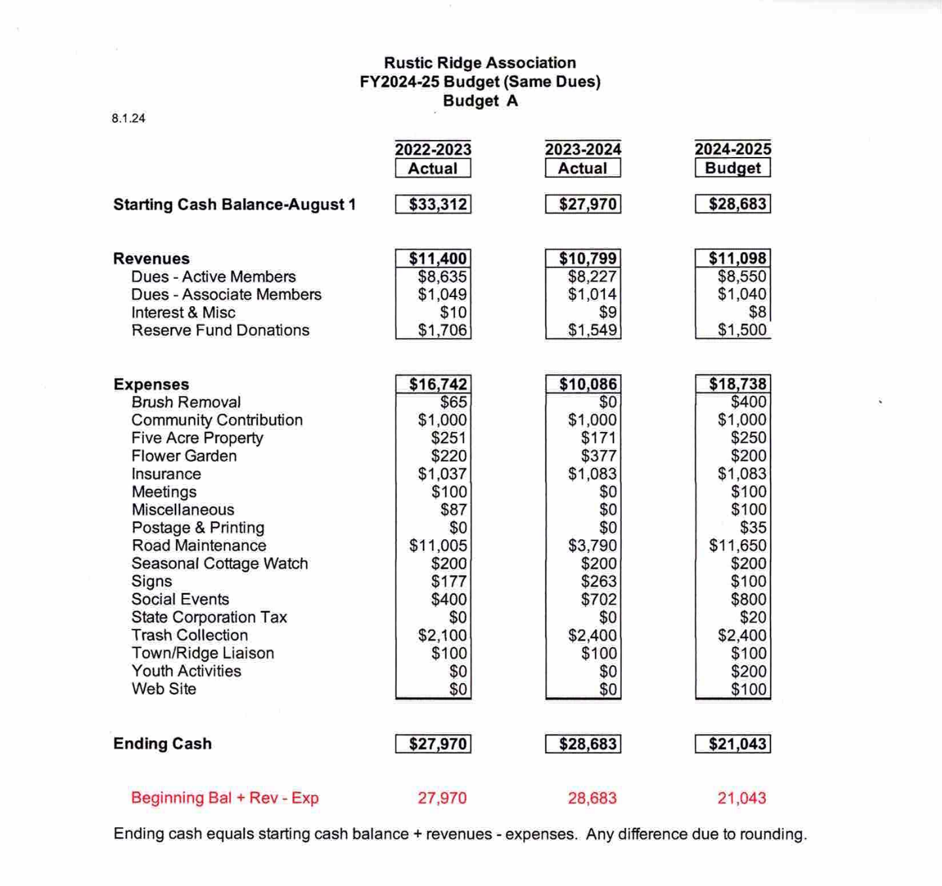
August 3, 2024
Rustic Ridge Association Annual Meeting
Road Committee Report

Budget summary
Our actual expenditures for the past year were lower than usual because our main project on Cliff Road was deferred. For 2024-2025 our projected expenses return to a more typical amount.

Maintenance
This year we did the usual annual maintenance with road blowing, side trimming, and culvert clearing. We also added a new caution sign at the top of the steep hill on Ledge Way.

A major pot hole on The Willows was filled with dirt when the culvert was cleared and there was no charge.

Repaving
The scheduled repairs to the top Ridge, Cliff Road, were deferred until the Town completes its work on upper North Lane and are now shown in the 2024-2025 budget. As you know the Town plans to regrade upper North Lane and add more culverts to improve runoff. This has been rescheduled from fall 2023 to spring 2024 and now deferred to fall 2024. The junction between North Lane and Cliff Road has deteriorated further so we hope this work gets completed soon. Upper North Lane will be closed during repairs, and we will notify everyone in advance about the schedule.

When North Lane is finished, we can work on Cliff Road, that needs a better road bed, new paving, and new gravel for the long end section that connects with the Fire Trail. At that time, we hope to improve the swale on the side of the road. Cliff Road cannot be widened since it is in a narrow section between a stream and rock ledge.

The 6th Ridge, Heath Road, is also in our future plans but we will hold out on that until Cliff Road has been addressed.

Storm repairs
A mid-summer storm downed trees from Kip Kritchko’s property onto Steve Severance’s cottage and Ledge Way. In a team effort Catherine Broadhead alerted us, Kurt Nelson took photos, and Steve Severance cleared the road that morning. Kip Kritchko has agreed to reimburse the Ridge Association for the $200 paid to clear the road and to pay the arborist Tim Nichols who removed dangerous hanging tree limbs. This is a reminder to everyone. Please maintain your trees!!!

Respectfully submitted,
Lucy and Phil Livingston

Rustic Ridge Annual Meeting 8.03.2024
2024-2025 Road Committee Budget

2023-2024 Road Committee Budget
Proposed Actual
Road sweeping & Culvert clearing $1,600 $1,850

Brush hog clearing $1,500 $1,600

Manual trimming West Lane $400 $140

Cliff Road paving and gravel $7,500 $0

Willows pothole repair $650 $0

Post storm tree and limb removal $0 $200

Caution sign for Ledge Way $0 $83

Total 2023-2024 $11,650 $3,873

2024-2025 Road Committee Proposed Budget

Road sweeping and culvert clearing $1,850

Brush Hog clearing $1,600

Manual trimming West Lane $160

Cliff Road paving and gravel $7,500

Post storm repairs $200

Total proposed 2024-2025 $11,310 $

Annual Report of the Rustic Ridge Association

Town of Northfield Representative August 2024

Another year has passed here in Northfield. Thomas Aquinas College has a full enrollment, we now have 2 new permanent principles (the high school and elementary school), the Schell Bridge construction has been postponed our new Police Department is well staffed and our Emergency Complex has been voted down as well as a possible stop gap that wasn't workable.

Northfield's Business Climate

Cameron's Winery is now Cameron's Winery and The Back Room Brewery. Paul brews his own beer, and they also have ciders. Some of the wines have once again won prizes at the annual gathering of wine makers. They have outdoor garden seating that is quite lovely and the Charcuterie menu has been expanded. They use all local ingredients in their brews, so it really is a local.

4 Star Brewery on Pine Meadow is another great place to chill. They grow their own

hops and you can see the vats through the window. The library Trivia Night has been held there most of this year so look for the next one and come on down! They often have live music and food from a food truck which uses local ingredients, too!

We're still waiting for the eating area next to the IGA and the Notch to open. There has been no activity at the IGA, or the Notch. When I asked Jody when they would open, he smiled broadly and said he didn't know. Ask him when you're in the IGA. We need these venues in town.

• The Northfield Trails Association has been keeping up the trails. Many are still hiking and enjoying the outdoors. Barb and Sam Richardson are still keeping the trails and are a good source for hikes.

• The Thursday Road races continue to draw many folks who continue to enjoy them. Bob Emberley posts the time on NextDoor each week. If you're not up for a run, you can walk it all, or part of it. I'm sure some of your young'uns would have fun. Bob has run this for several summers. When It's too hot, it is canceled.

Annual Report of the Rustic Ridge Association

Sept, they applied for a grant with "Reconnecting Communities and Neighborhoods" through the U.S. Department of Transportation. Congresspeople were contacted and the board reached out to townsfolk to write letters in support. I believe we're still waiting to hear. I noticed as a future the agenda item for the Selectboard, that there will be a debrief on the Schell Bridge at a future date. The meetings are at 6pm. And just a reminder, it was voted by the Selectboard to name the bridge "Pauchaug -Schell Bridge Greenway". This is a nod to the heritage of the area and that it's part of the Connecticut River Greenway State Park. The entrance will incorporate some of the original bridge material and will give some history in plaques and signs. There were two options, and I'm not sure one has been chosen and it will be posted when the decision has been made.

Town Government

The board recently elected new officers: Bernie Boudreau is the chair, Sarah Kerns is the vice chair, David McCarthy, a new member, is the clerk. He was on the Finance Committee. Bernie Boudreau is in his last year, and no indication yet if he will run again. Heath Cummings will not run again, Bee Jacque won't be up for election, so we'll have 1 seat in the next election. Skip gives periodic updates via Code Red. You can sign up for that on the town website. These have been storm warnings, road closers and the like. Skip was given another extension for his service. Our EMS director is stepping down, so a search is on. Mark had some issues in Orange, and at this point can't be in the ambulance.

The Police Dept has 5 full time officers who you will find out on patrol, including the chief. There is not town overnight coverage, so the State Police are still available for us.

The Fire Dept., EMS and Police Dept. are still looking at options for a new building as an emergency services complex. It's unclear if the committee will continue to look at a space for all the ER services, or will look for separate spaces. The town has purchased the land next to the library with the idea that it would be the future site of the Emergency Services Complex and now I'm not sure how that space will be used, or if it will remain trails. The town website under "Emergency Services Facility Committee" will give you updates. Still no gas station...

On a personal note, I love being a grandma! My grandson calls me Ami and my granddaughter calls me Aji, which is shortened from Ama-ji, a Nepali term which ruffly translates to 'Wise

